Assignment 9

* Create a *StatefulWidget* that displays an image. The image should be centered on the screen. The image should change to another image when the user presses a button. You need to add five different images in the *assets* folder. When the user reaches the last image, the image should change back to the first image.
* Reformat the code from the previous exercise to display the images in a random order. In other words, the images should be displayed in a random order every time the user presses the button.

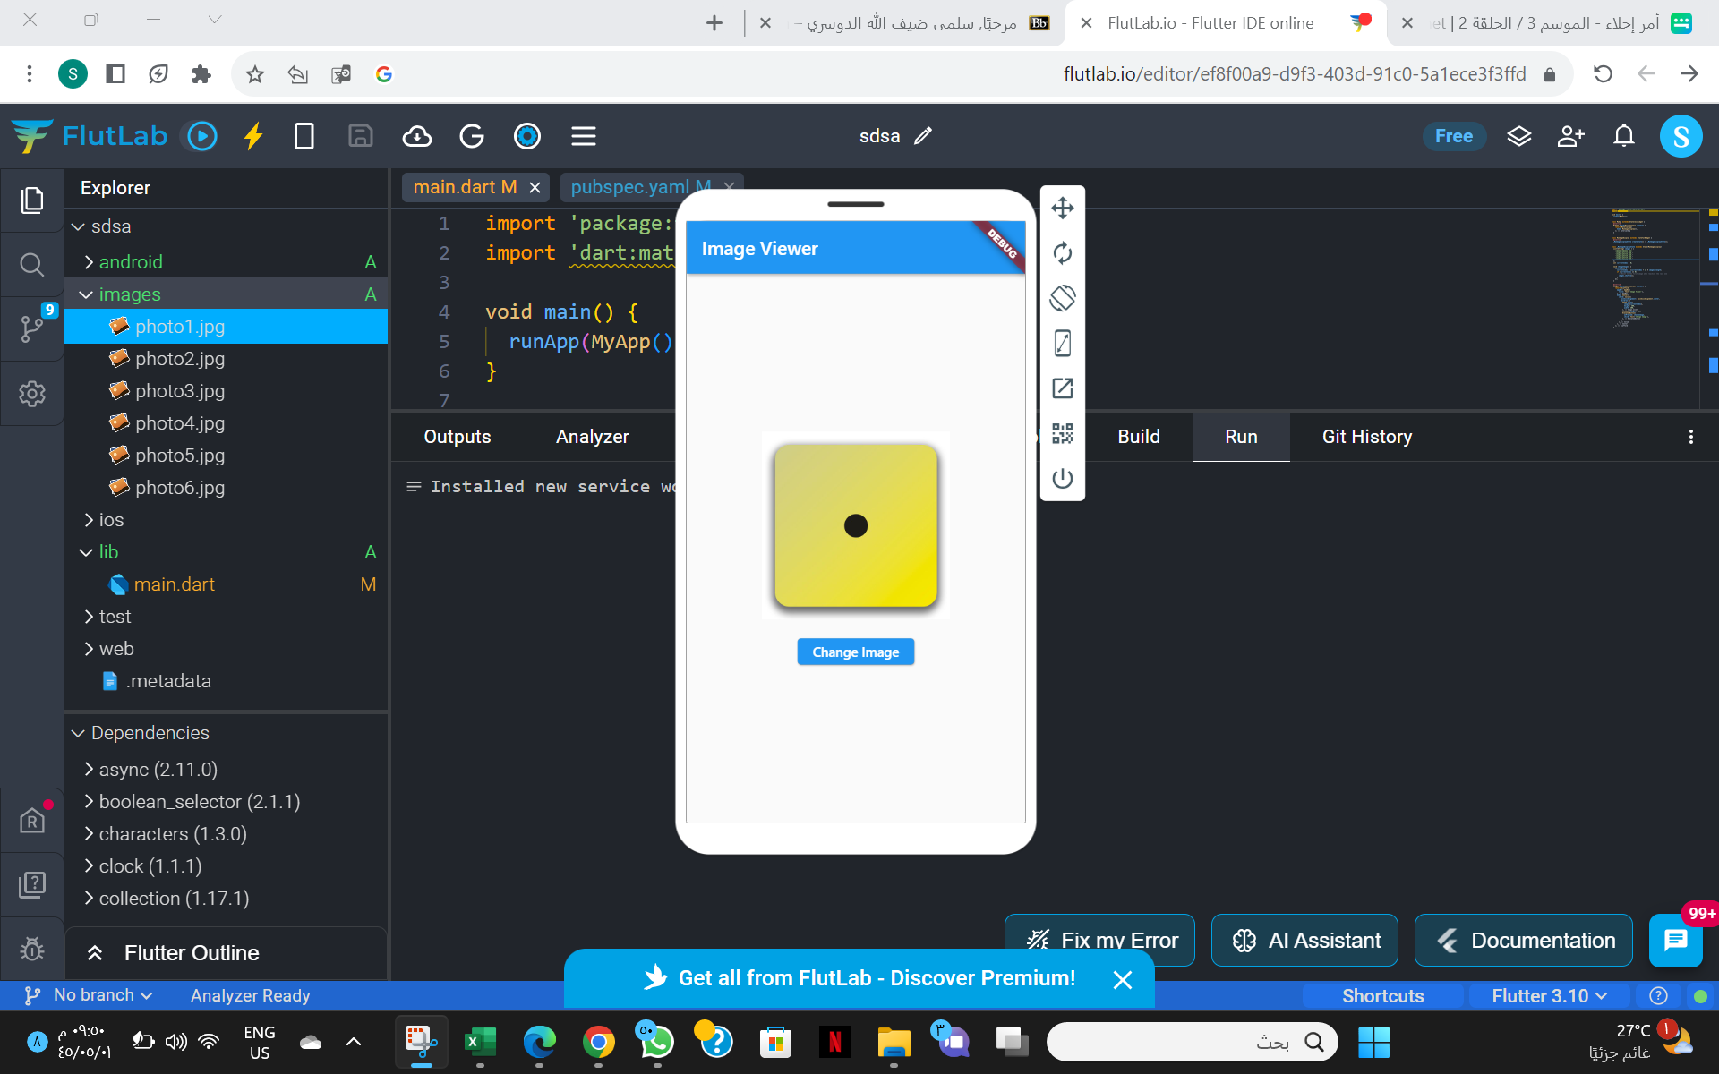

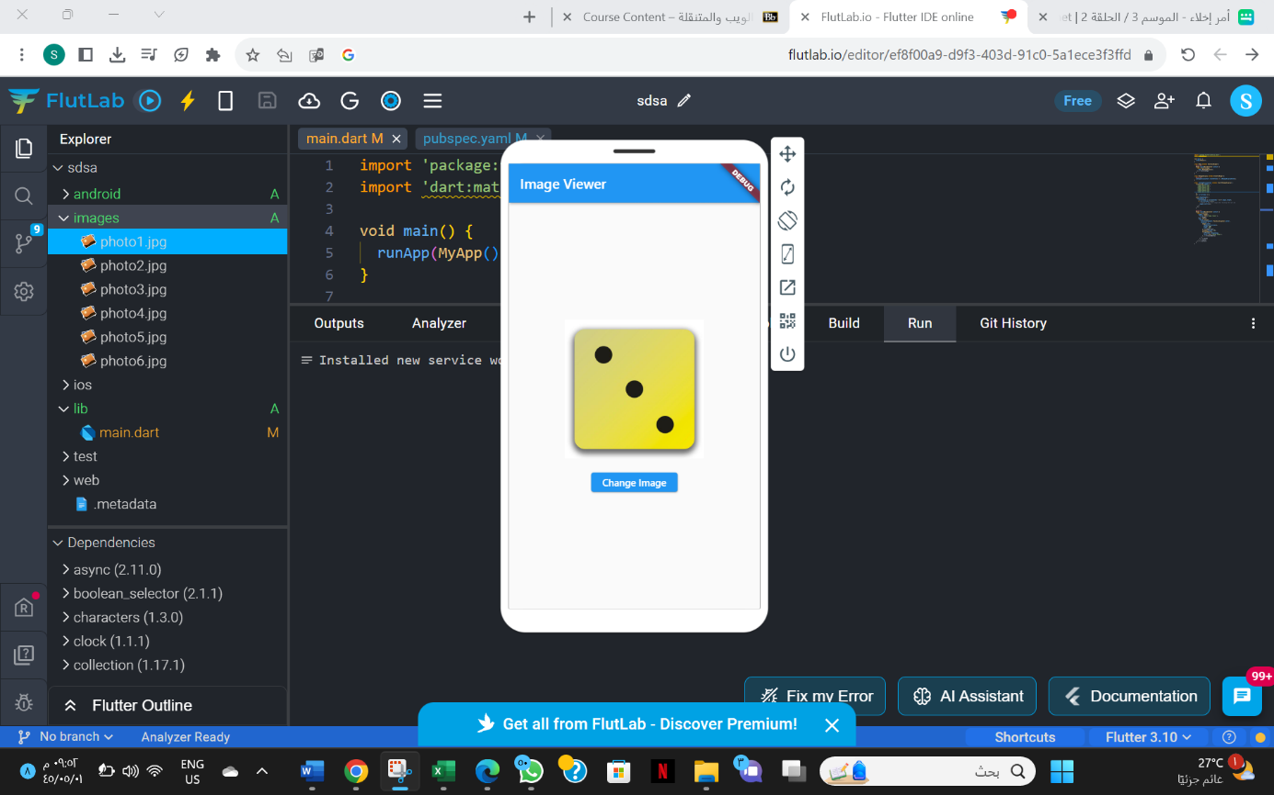

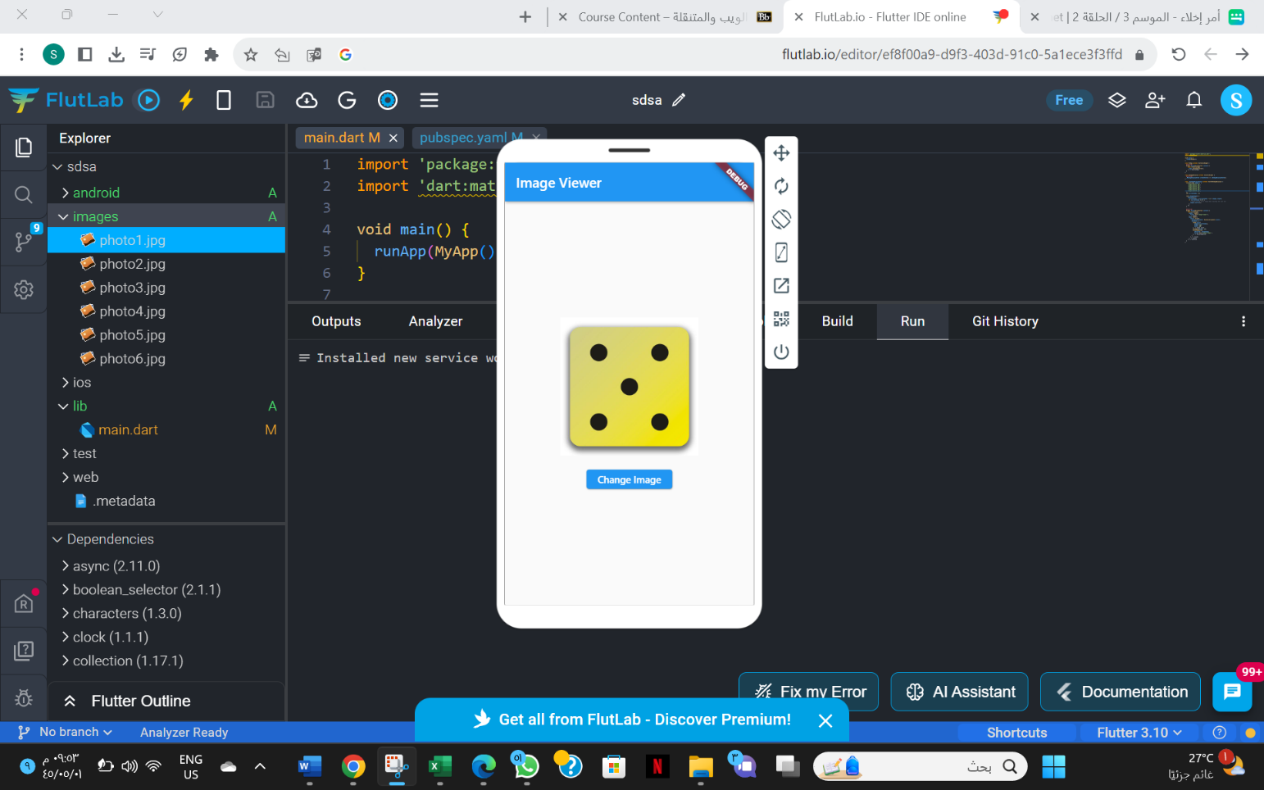

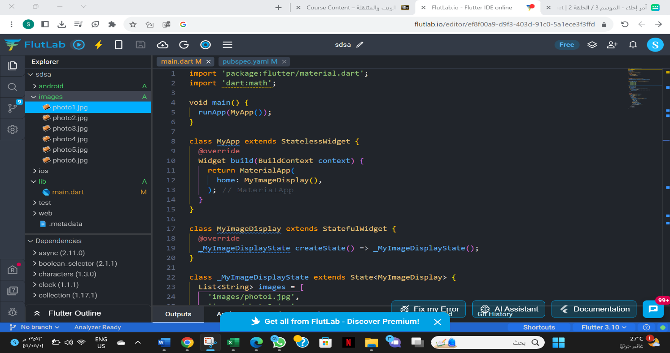

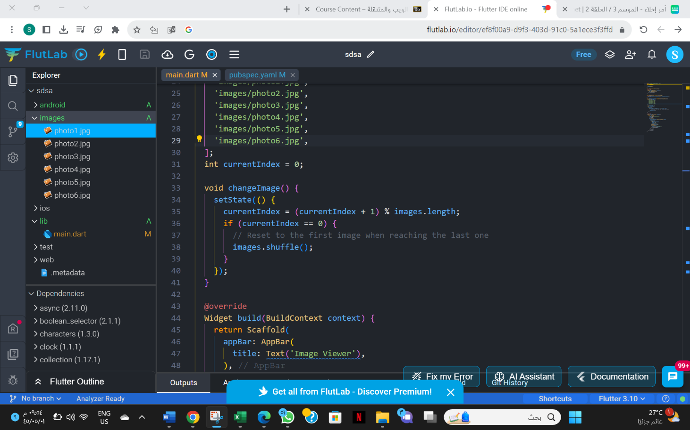

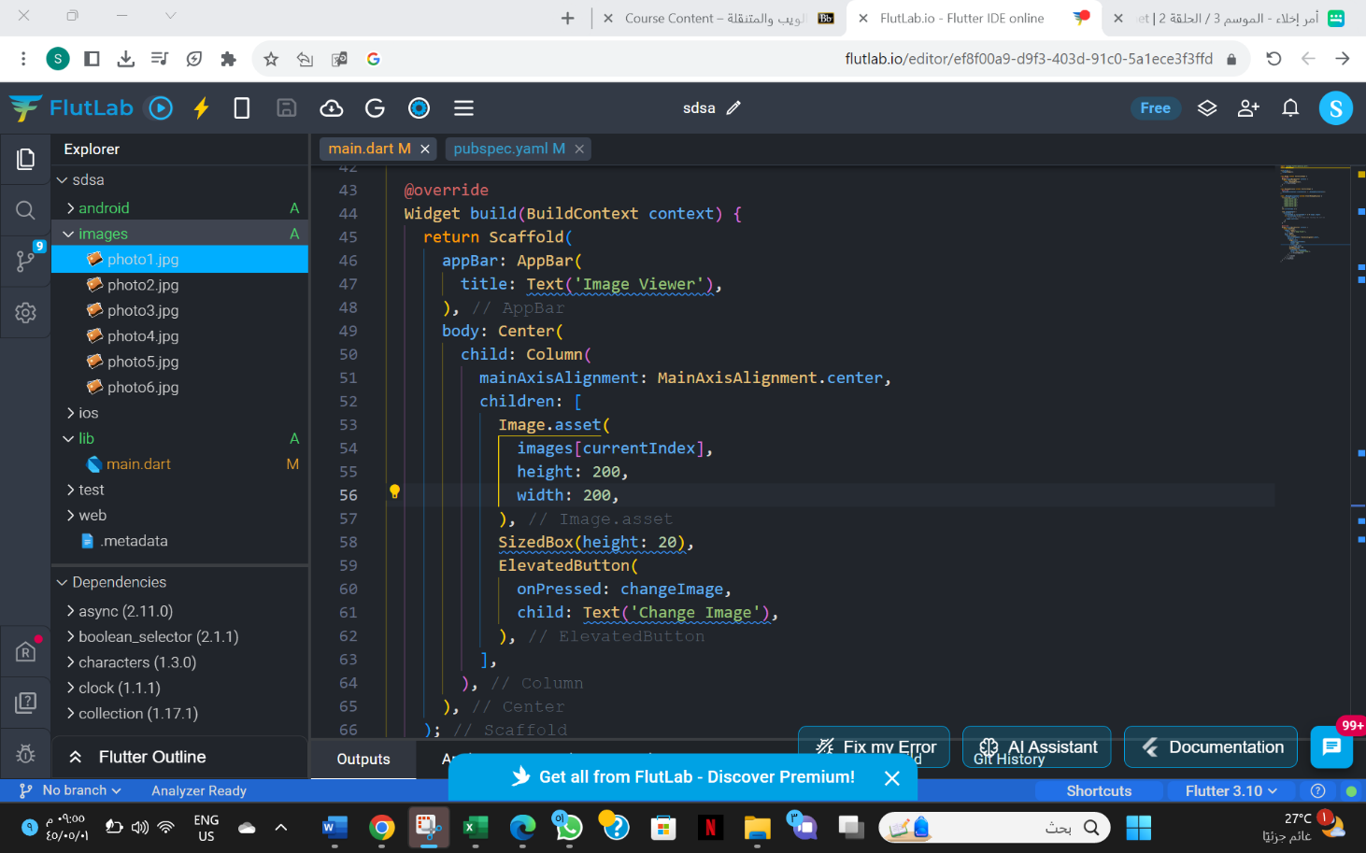

import 'package:flutter/material.dart';

import 'dart:math';

void main() {

  runApp(MyApp());

}

class MyApp extends StatelessWidget {

  @override

  Widget build(BuildContext context) {

    return MaterialApp(

      home: MyImageDisplay(),

    );

  }

}

class MyImageDisplay extends StatefulWidget {

  @override

  _MyImageDisplayState createState() => _MyImageDisplayState();

}

class _MyImageDisplayState extends State<MyImageDisplay> {

  List<String> images = [

    'images/photo1.jpg',

    'images/photo2.jpg',

    'images/photo3.jpg',

    'images/photo4.jpg',

    'images/photo5.jpg',

    'images/photo6.jpg',

  ];

  int currentIndex = 0;

  void changeImage() {

    setState(() {

      currentIndex = (currentIndex + 1) % images.length;

      if (currentIndex == 0) {

        // Reset to the first image when reaching the last one

        images.shuffle();

      }

    });

  }

  @override

  Widget build(BuildContext context) {

    return Scaffold(

      appBar: AppBar(

        title: Text('Image Viewer'),

      ),

      body: Center(

        child: Column(

          mainAxisAlignment: MainAxisAlignment.center,

          children: [

            Image.asset(

              images[currentIndex],

              height: 200,

              width: 200,

            ),

            SizedBox(height: 20),

            ElevatedButton(

              onPressed: changeImage,

              child: Text('Change Image'),

            ),

          ],

        ),

      ),

    );

  }

}